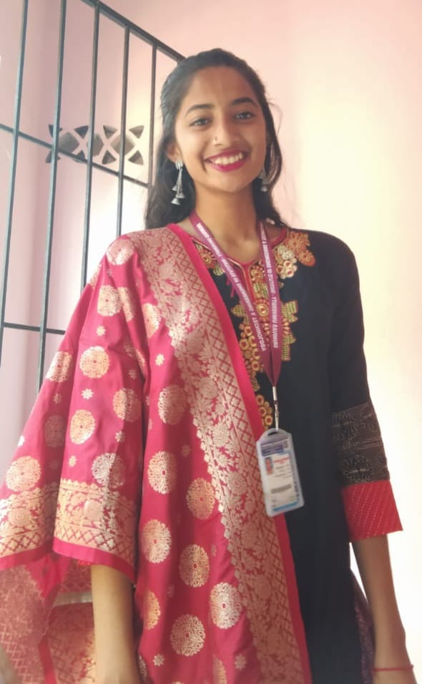 RAKSHITA PRADEEP NAIK

undergraduate STUDENT

+918088179986

rakshitanaik17@gmail.com

jogalse kantri road ankola

# Objective

To utilize my expert editorial skills to deliver error-free, engaging, and high-quality content for a variety of clients and industries.

# Skills & Abilities

* BASIC WEB FRONTEND:

HTML, CSS, JAVASCRIPT

* BASIC BACKEND:

JAVA, PYTHON

* BASIC DBMS – SQL
* ADDITIONAL SKILLS:

PRESENTATION, DEBUGGING, LEADERSHIP

HARDWORKING, COMMUNICATION, FAST LEARNER

# education

## SSLC

### P.M. HIGH SCHOOL, ANKOLA

* MARKS: 81.76%

## 2020-2021 PUC

### HIMALAYA P. U. COLLEGE, ANKOLA

### MARKS: 85.86%

* 1. **BTECH-CS(**PURSUVING**)**
* SRINIVAS UNIVERSITY, INSTITUTE OF ENGINEERING AND TECHNOLOGY, MUKKA, MANGALORE
* SGPA:

1ST SEM: 8.63

2NDSEM: 9.50

3RDSEM: 8.7

# PROJECTS

## MINOR PROJECTS: **1.** IOT BASED HOME AUTOMATION

TEAM SIZE: INDIVIDUALS

# internships

AUG 2023 – SEP 2023 **THANIYA TECHNOLOGY**

# COURSES AND CERTIFICATION

* INTRODUCTION TO PYTHON, BY INFOSYS SPRINGBOARD
* BASICS OF PYTHON, BY INFOSYS SPRINGBOARD
* CHATGPT FOR EVERYONE, BY GUVI
* GAME DEVELOPMENT USING PYGAME, BY GUVI

# curriculum activites

* TEAM LEADER

As having a good leadership quality, assigned as a Team leader in school, college.

* Participated in

# CO-Curriculum activites

# PERSONAL DETAILS

* DOB: 19-06-2003
* KNOWN LANGUAGE: ENGLISH, KANNADA, HINDI
* NATIONALITY: INDIAN
* HOBBIES: DANCING, SINGING, DRAWING, READING

# DECLARATION

I hereby declare that the above-mentioned information is true to the best of my belief and knowledge.

Date: 26-09-2022 RAKSHITA PRADEEP NAIK

Place: MUKKA